Autonomous Swarm Drones Exploration using Hybrid Frontier-Tracing and Ray-Casting Frontier Detection
Sugiarto Cokrowibowo^{1,a,b}, Rustan Tarakka ^{2,a}, Andi Amijoyo Mochtar ^{3,a,*}
ª Department of Mechanical Engineering, Universitas Hasanuddin, Makassar, Indonesia
^{b} Department of Informatics, Universitas Sulawesi Barat, Majene, Indonesia

*E-mail: andijoyo@unhas.ac.id

¹ 0009-0002-0273-764X
² 0000-0002-6083-650X
³ 0000-0002-5721-5083

Abstract. Frontier-based exploration has become a fundamental paradigm in robotic navigation, where frontiers represent the dynamic boundary between known and unknown regions. The effectiveness of this approach depends heavily on the speed and accuracy of frontier detection, as faster detection not only accelerates the overall exploration process but also enhances decision-making quality through more up-to-date environmental information. In this paper, we propose a hybrid frontier detection method for autonomous swarm drone exploration that integrates the Frontier-Tracing Frontier Detection (FTFD) algorithm with a ray-casting strategy. The FTFD component exploits previously identified frontiers and scan endpoints to efficiently update new exploration targets, while ray casting provides accurate detection of boundaries in the drone’s immediate surroundings. This integration is particularly suited for drones equipped with four directional sensors, thereby enabling full 360° situational awareness. Simulation results within a grid-based environment demonstrate the effectiveness of the proposed method in achieving efficient and scalable swarm exploration, validating its potential for real-world multi-agent navigation tasks.
Keywords: unknown environment, swarm drones exploration, ray casting, frontier tracing, frontier detection
1. Introduction
Unmanned Aerial Vehicles (UAVs), commonly known as drones, are aircraft systems designed to operate without an onboard human pilot. These platforms can be remotely controlled or programmed to function autonomously through integrated electronic components such as sensors, microcontrollers, and communication modules [1]. UAVs are increasingly recognized for their versatility in executing diverse missions, ranging from data acquisition to exploration, while minimizing the need for direct human intervention. Their capability to operate effectively in hazardous or inaccessible environments makes them highly valuable for autonomous applications that would otherwise pose significant risks to human safety [2]. Since their emergence, UAVs have significantly transformed diverse industries by simplifying complex tasks, streamlining workflows, and enhancing operational efficiency. They have been widely adopted for applications such as aerial photography, delivery services, environmental monitoring, disaster response, agriculture, weather forecasting, wildlife tracking, law enforcement, entertainment, and military operations [3]. In disaster scenarios, UAVs provide real-time aerial surveillance, assist in locating injured individuals, and demonstrate clear advantages over conventional methods such as helicopters or human search chains by offering faster, safer, and more precise responses [4]. Their integration with advanced technologies, including high-resolution cameras, sensors, and radar, further supports disaster victim identification (DVI) and enhances disaster management strategies [5]. Unlike larger aerial platforms, UAVs can access confined or hazardous areas and deliver detailed close-range visual data, offering critical capabilities unattainable through traditional approaches [3][6].
Micro Aerial Vehicles (MAVs), often referred to as small drones, are compact and lightweight aerial robots increasingly deployed across various domains. Their designs include multirotor, flapping-wing, fixed-wing, morphing, and hybrid configurations [7][8][9]. Among them, quadrotors have gained prominence due to their superior maneuverability, vertical take-off capability, and relatively simple design [10]. Typically weighing around 100 grams or less and comparable in size to a human hand [11], MAVs are particularly suited for indoor exploration in hazardous environments. Their small form factor and agility enable safe operation near humans, while their lightweight design minimizes risks of environmental or human damage in case of collision [9][12]. The compact size of MAVs imposes inherent limitations, including short flight endurance, restricted sensor range, and limited power capacity, rendering them unsuitable for large-scale tasks when operating individually [9][13]. These constraints have stimulated significant interest in swarm-based MAV systems, where collective cooperation enhances effectiveness, much like social behaviors observed in biological systems [14][15]. Typically operating without GPS and designed for indoor environments, MAVs require alternative exploration and navigation strategies [16]. Swarm robotics leverages distributed control, with each robot relying on local sensing and independent decision-making, while collaboration enables the team to achieve goals unattainable by a single unit. Such cooperation offers key advantages, including redundancy reduction, faster task execution through parallelization, and the capacity to perform complex missions collectively [17][9].
Exploration refers to the movement of robots in unknown environments with the goal of acquiring information or constructing maps to support subsequent navigation [18][19]. Mapping is fundamental for effective localization and path planning, with the primary objective of minimizing travel distance while building a comprehensive representation of the environment. Autonomous exploration, a classical challenge in mobile robotics, has wide applications in search and rescue, automated cleaning systems, and logistics management [20][21]. Research on exploring and mapping unknown, unstructured environments is a critical area in robotics [22]. In such scenarios, robots operate without prior knowledge of environmental boundaries or obstacle locations [23]. Exploration of unknown areas often entails high costs and safety risks for humans [24]. The primary objectives are not only to ensure safety and collision avoidance but also to maximize information acquisition about the environment [25]. The core question of exploration is what is known about the environment and where to move to maximize information gain [26]. With advancements in swarm UAV technology, exploration has extended toward multi-robot collaboration, enabling more efficient and scalable mapping. UAVs, in particular, offer high flexibility for autonomous exploration, as they can navigate complex spaces, overcome ground-level obstacles, and generate detailed three-dimensional maps [27][28]. Research on multi-robot coverage path planning typically assumes a known environment, relying on graph-based or Voronoi-based methods, as well as metaheuristic and nature-inspired algorithms such as ACO, PSO, and genetic algorithms [29][30][31]. These approaches generally operate on pre-defined maps and iterative optimization. In contrast, autonomous exploration addresses unknown environments, where robots lack prior knowledge and must initially perform blind search before path planning [32][28]. Unlike ground robots, MAVs face stricter constraints such as limited power, computation, memory, lack of GPS, and the need for smooth trajectories, making autonomous exploration more challenging [28]. To overcome these limitations, lightweight bio-inspired algorithms enable swarm MAVs to maximize coverage while minimizing time and redundancy under resource constraints [33], [34].
Frontier-based exploration (FBE), first introduced by Yamauchi [18][19], has become a widely adopted strategy for robotic navigation in unknown environments due to its efficiency, precision, and low computational cost [35][23][36][21]. The method identifies frontiers boundaries between explored and unexplored regions to guide the movement of single or multiple agents, making it particularly well-suited to the computational and memory constraints of MAVs [37][27]. Several frontier detection methods have been proposed, ranging from Naïve and Wavefront Frontier Detector (WFD) to more advanced approaches such as Fast Frontier Detection (FFD), Expanding-Wavefront Frontier Detection (EWFD), and Frontier-Tracing Frontier Detection (FTFD), with FTFD demonstrating superior speed and efficiency [38][39]. Building on these advances, this paper proposes a hybrid frontier detection approach that integrates FTFD with ray-casting to enhance autonomous swarm drones exploration in unknown environments.
2. Proposed Method
The proposed method integrates Frontier-Tracing Frontier Detection (FTFD) with ray-casting to enable efficient autonomous swarm drones exploration. At each time step t₁ range measurements from four orthogonally oriented sensors are used in a ray-casting process to identify candidate frontier endpoints. These candidates, together with existing frontier boundaries, are refined through FTFD to update the frontier set from F_{t-1} to F_{t}. Each drone then selects the nearest frontier and navigates toward it using a shortest-path strategy based on Breadth-First Search (BFS). Upon reaching a frontier, it is removed from the set, while unexplored frontiers remain available as future targets. In swarm deployment, this hybrid mechanism allows multiple agents to coordinate frontier allocation, minimize redundancy, and improve overall coverage efficiency under limited computational resources. Figure 1 presents the results of frontier detection obtained through the ray-casting algorithm.
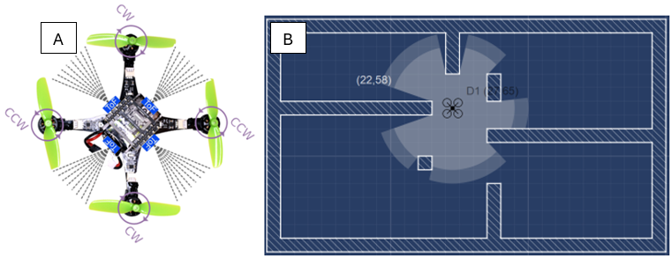
Figure 1(A) Representation of four ranging sensors facing forward, backward, left, and right on a drone; (B) Frontier Detection using Ray-Casting Algorithm
Algorithm: Hybrid Frontier-Tracing and Ray-Casting Frontier Detection
Input : Grid Map (unknown map with wall and obstacles) , Drones
Output : Explored map using Hybrid Frontier-Tracing and Ray-Casting Frontier Detection
Step 1 : initialization
Step 2 : Calculated must explored cells
Step 3 : Detect Frontiers for every drone using ray-casting algorithm
Step 4 : Update detected frontiers using FTFD
Step 5 : Drones go to their nearest frontiers using BFS
Step 6 : Remove visited frontier from frontier set and set free area
Step 7 : Repeat step 3 until no frontier remains in the frontier set.

The Hybrid Frontier-Tracing and Ray-Casting Frontier Detection algorithm is designed to optimize autonomous swarm drone exploration in unknown environments. In this approach, each drone maintains its own frontier set, ensuring independent exploration tasks and preventing inter-drone collisions. The Frontier-Tracing Frontier Detection (FTFD) algorithm plays a central role in improving the efficiency of frontier updates by employing a memoization technique, in which previously detected frontiers are retained in the frontier set until they are explicitly visited by a drone. This strategy reduces redundant computations and accelerates the overall exploration process. Complementing this, the ray-casting algorithm provides a realistic simulation of range-finder sensor behavior. Each drone is equipped with four sensors placed on its four sides, with each sensor covering a 45° field of view and a sensing range of approximately 3 meters, effectively achieving 360° environmental perception. Such a configuration can be practically realized using Time-of-Flight (ToF) sensors, enabling accurate detection of obstacles and exploration boundaries.

Algorithmically, the process begins with initialization of the grid map and swarm (Step 1), followed by calculating the total number of cells that must be explored (Step 2). Each drone then performs frontier detection using the ray-casting algorithm (Step 3), after which the detected frontiers are refined and updated through FTFD with memoization (Step 4). The drones navigate to their nearest frontier cells using a Breadth-First Search (BFS) path-planning strategy (Step 5). Once a frontier is reached, it is removed from the frontier set and the corresponding area is marked as explored (Step 6). These steps are iteratively repeated until no frontier remains in the frontier sets of all drones (Step 7), thereby ensuring complete and efficient exploration of the environment.
3. Result and Discussion
The simulation was implemented in the JavaFX framework within a 50 × 50 grid-based occupancy map (cell size: 10 pixels). A swarm of three drones, each equipped with a ray-casting sensor providing a 360° field of view and a 10-cell sensing radius, was deployed. The environment included walls and static obstacles to define navigable and restricted areas. Exploration was conducted by iteratively detecting and navigating toward frontiers, with each drone maintaining its own frontier allocation set to ensure coverage efficiency and collision avoidance.
The simulation results, as presented in Figure 2, were successfully implemented using the JavaFX framework within a 50 × 50 grid-cell workspace. A swarm consisting of three autonomous drones, each equipped with a sensor field of view (FOV) spanning 10 cells, was deployed to explore the environment. The experimental outcome indicated that a total of 2,057 cells were effectively explored during the mission. The proposed Hybrid Frontier-Tracing and Ray-Casting Frontier Detection approach demonstrated significant effectiveness: the Frontier-Tracing Frontier Detection (FTFD) component ensured continuous and efficient frontier updates, while the ray-casting algorithm provided accurate perception of the drones’ surrounding environment. The integration of these two complementary methods enabled real-time visualization of dynamic frontier updates in parallel with environmental sensing. Collectively, these findings validate the robustness and applicability of the proposed hybrid strategy for autonomous swarm-based exploration tasks, particularly in complex and discretized environments.

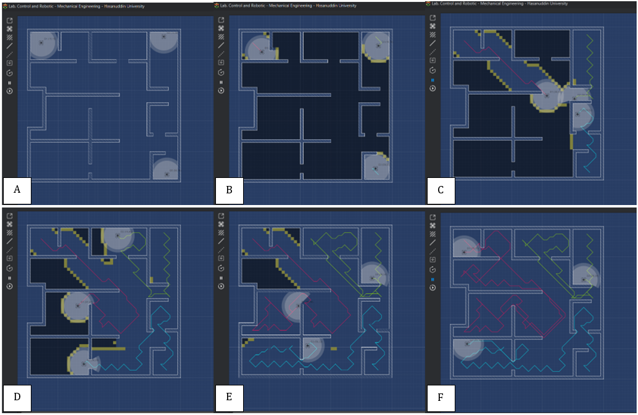
Figure 2 Simulation result with 50 x 50 grid cells
4. Conclusion
This study has introduced a hybrid frontier detection framework for autonomous swarm drone exploration, integrating the Frontier-Tracing Frontier Detection (FTFD) algorithm with the ray-casting method, and implemented within the JavaFX simulation environment. The ray-casting algorithm effectively modeled the sensing capabilities of drones by simulating multi-directional range detection, ensuring accurate environmental perception in a discretized grid map. To improve computational efficiency, memoization was incorporated into the FTFD algorithm, leveraging the recurrent intersection of new sensor data with previously identified frontiers to accelerate frontier updates. The simulation results demonstrated that the proposed hybrid strategy enabled the swarm of drones to achieve complete and collision-free exploration of a grid-based environment, with efficient frontier allocation and real-time adaptability. These findings validate the robustness and applicability of the approach, highlighting its potential for deployment in scalable, autonomous, and cooperative exploration scenarios across structured and unstructured environments.
For future work, this research will be extended by adapting the proposed frontier-based exploration algorithm to support cooperative deployment in larger and more complex environments. To enable decentralized coordination within the swarm, a stigmergy-inspired mechanism will be explored, where digital pheromones are employed as an indirect communication medium. By embedding environmental markers as carriers of information, drones will be able to coordinate exploration activities without relying exclusively on direct inter-agent communication. This strategy is anticipated to significantly improve the scalability, robustness, and efficiency of multi-drone exploration, making the approach more suitable for real-world scenarios characterized by dynamic and uncertain conditions.
References
[1] A. Hemmati, M. Zarei, and A. Souri, “UAV-based Internet of Vehicles: A systematic literature review,” Intelligent Systems with Applications, vol. 18, no. April, p. 200226, 2023, doi: 10.1016/j.iswa.2023.200226.
[2] S. A. H. Mohsan, N. Q. H. Othman, Y. Li, M. H. Alsharif, and M. A. Khan, “Unmanned aerial vehicles (UAVs): practical aspects, applications, open challenges, security issues, and future trends,” Intell Serv Robot, vol. 16, no. 1, pp. 109–137, Mar. 2023, doi: 10.1007/s11370-022-00452-4.
[3] A. A. Laghari, A. K. Jumani, R. A. Laghari, and H. Nawaz, “Unmanned aerial vehicles: A review,” Cognitive Robotics, vol. 3, no. December 2022, pp. 8–22, 2023, doi: 10.1016/j.cogr.2022.12.004.
[4] R. V. Meshcheryakov et al., “An application of swarm of quadcopters for searching operations,” IFAC-PapersOnLine, vol. 52, no. 25, pp. 14–18, 2019, doi: 10.1016/j.ifacol.2019.12.438.
[5] S. M. S. Mohd Daud et al., “Applications of drone in disaster management: A scoping review,” Science and Justice, vol. 62, no. 1, pp. 30–42, 2022, doi: 10.1016/j.scijus.2021.11.002.
[6] A. Farooq, A. Anastasiou, N. Souli, C. Laoudias, P. S. Kolios, and T. Theocharides, “UAV Autonomous Indoor Exploration and Mapping for SAR Missions: Reflections from the ICUAS 2022 Competition,” 2022 19th International Conference on Ubiquitous Robots, UR 2022, vol. 2022-Janua, pp. 621–626, 2022, doi: 10.1109/UR55393.2022.9866527.
[7] V. Kumar and N. Michael, “Opportunities and Challenges with Autonomous Micro Aerial Vehicles,” vol. 100, 2017, pp. 41–58. doi: 10.1007/978-3-319-29363-9_3.
[8] K. McGuire, M. Coppola, C. De Wagter, and G. De Croon, “Towards autonomous navigation of multiple pocket-drones in real-world environments,” IEEE International Conference on Intelligent Robots and Systems, vol. 2017-Septe, no. September, pp. 244–249, 2017, doi: 10.1109/IROS.2017.8202164.
[9] M. Coppola, K. N. McGuire, C. De Wagter, and G. C. H. E. de Croon, “A Survey on Swarming With Micro Air Vehicles: Fundamental Challenges and Constraints,” Front Robot AI, vol. 7, no. February, 2020, doi: 10.3389/frobt.2020.00018.
[10] S. Gupte, P. I. T. Mohandas, and J. M. Conrad, “A survey of quadrotor unmanned aerial vehicles,” Conference Proceedings - IEEE SOUTHEASTCON, 2012, doi: 10.1109/SECon.2012.6196930.
[11] S. Bonato, S. C. Lambertenghi, E. Cereda, A. Giusti, and D. Palossi, “Ultra-low Power Deep Learning-based Monocular Relative Localization Onboard Nano-quadrotors,” Proc IEEE Int Conf Robot Autom, vol. 2023-May, pp. 3411–3417, 2023, doi: 10.1109/ICRA48891.2023.10161127.
[12] A. Kushleyev, D. Mellinger, and V. Kumar, “Towards a swarm of agile micro quadrotors,” Robotics: Science and Systems, vol. 8, no. July 2012, pp. 217–224, 2013, doi: 10.7551/mitpress/9816.003.0033.
[13] Y. Alqudsi and M. Makaraci, “UAV swarms: research, challenges, and future directions,” Journal of Engineering and Applied Science, vol. 72, no. 1, pp. 1–24, 2025, doi: 10.1186/s44147-025-00582-3.
[14] A. Batinović, J. Oršulić, T. Petrović, and S. Bogdan, “Decentralized Strategy for Cooperative Multi-Robot Exploration and Mapping,” IFAC-PapersOnLine, vol. 53, no. 2, pp. 9682–9687, 2020, doi: 10.1016/j.ifacol.2020.12.2618.
[15] S. Garnier, J. Gautrais, and G. Theraulaz, “The biological principles of swarm intelligence,” Swarm Intelligence, vol. 1, no. 1, pp. 3–31, 2007, doi: 10.1007/s11721-007-0004-y.
[16] Y. Chang, Y. Cheng, U. Manzoor, and J. Murray, “A review of UAV autonomous navigation in GPS-denied environments,” Rob Auton Syst, vol. 170, no. September, p. 104533, 2023, doi: 10.1016/j.robot.2023.104533.
[17] N. Nedjah and L. S. Junior, “Review of methodologies and tasks in swarm robotics towards standardization,” Swarm Evol Comput, vol. 50, p. 100565, 2019, doi: 10.1016/j.swevo.2019.100565.
[18] B. Yamauchi, “A frontier-based exploration for autonomous exploration,” IEEE International Symposium on Computational Intelligence in Robotics and Automation, Monterey, CA, pp. 146–151, 1997, [Online]. Available: https://pdfs.semanticscholar.org/9afb/8b6ee449e1ddf1268ace8efb4b69578b94f6.pdf
[19] B. Yamauchi, “Frontier-based exploration using multiple robots,” Proceedings of the International Conference on Autonomous Agents, pp. 47–53, 1998, doi: 10.1145/280765.280773.
[20] S. Shen, N. Michael, and V. Kumar, “Autonomous indoor 3D exploration with a micro-aerial vehicle,” Proc IEEE Int Conf Robot Autom, pp. 9–15, 2012, doi: 10.1109/ICRA.2012.6225146.
[21] R. Wang, J. Zhang, M. Lyu, C. Yan, and Y. Chen, “An improved frontier-based robot exploration strategy combined with deep reinforcement learning,” Rob Auton Syst, vol. 181, no. June 2023, p. 104783, 2024, doi: 10.1016/j.robot.2024.104783.
[22] P. Arias-Perez, A. Gautam, M. Fernandez-Cortizas, D. Perez-Saura, S. Saripalli, and P. Campoy, “Exploring Unstructured Environments using Minimal Sensing on Cooperative Nano-Drones,” IEEE Robot Autom Lett, 2024, doi: 10.1109/LRA.2024.3486212.
[23] V. P. Tran, M. A. Garratt, K. Kasmarik, S. G. Anavatti, and S. Abpeikar, “Frontier-led swarming: Robust multi-robot coverage of unknown environments,” Swarm Evol Comput, vol. 75, no. January, p. 101171, 2022, doi: 10.1016/j.swevo.2022.101171.
[24] G. Pepe, M. Satler, and P. Tripicchio, “Autonomous exploration of indoor environments with a micro-aerial vehicle,” 2015 Workshop on Research, Education and Development of Unmanned Aerial Systems, RED-UAS 2015, no. November, pp. 43–52, 2016, doi: 10.1109/RED-UAS.2015.7440989.
[25] H. Oleynikova, Z. Taylor, R. Siegwart, and J. Nieto, “Safe Local Exploration for Replanning in Cluttered Unknown Environments for Microaerial Vehicles,” IEEE Robot Autom Lett, vol. 3, no. 3, pp. 1474–1481, 2018, doi: 10.1109/LRA.2018.2800109.
[26] C. Dornhege and A. Kleiner, “A frontier-void-based approach for autonomous exploration in 3d,” 9th IEEE International Symposium on Safety, Security, and Rescue Robotics, SSRR 2011, no. November 2011, pp. 351–356, 2011, doi: 10.1109/SSRR.2011.6106778.
[27] J. A. Caley, N. R. J. Lawrance, and G. A. Hollinger, “Deep learning of structured environments for robot search,” Auton Robots, vol. 43, no. 7, pp. 1695–1714, 2019, doi: 10.1007/s10514-018-09821-4.
[28] Y. Zhao, J. Zhang, and C. Zhang, “Deep-learning based autonomous-exploration for UAV navigation,” Knowl Based Syst, vol. 297, no. August 2023, p. 111925, 2024, doi: 10.1016/j.knosys.2024.111925.
[29] X. Huang, M. Sun, H. Zhou, and S. Liu, “A multi-robot coverage path planning algorithm for the environment with multiple land cover types,” IEEE Access, vol. 8, pp. 198101–198117, 2020, doi: 10.1109/ACCESS.2020.3027422.
[30] Y. Ning, T. Li, C. Yao, W. Du, and Y. Zhang, “HMS-RRT: A novel hybrid multi-strategy rapidly-exploring random tree algorithm for multi-robot collaborative exploration in unknown environments,” Expert Syst Appl, vol. 247, no. July 2023, p. 123238, 2024, doi: 10.1016/j.eswa.2024.123238.
[31] W. Firgiawan, S. Cokrowibowo, A. Irianti, and A. Gunawan, “Performance Comparison of Spider Monkey Optimization and Genetic Algorithm for Traveling Salesman Problem,” Proceeding - ICERA 2021: 2021 3rd International Conference on Electronics Representation and Algorithm, no. March 2023, pp. 191–195, 2021, doi: 10.1109/ICERA53111.2021.9538795.
[32] H. Zhao, Y. Guo, Y. Liu, and J. Jin, “Multirobot unknown environment exploration and obstacle avoidance based on a Voronoi diagram and reinforcement learning,” Expert Syst Appl, vol. 264, no. November 2024, p. 125900, 2025, doi: 10.1016/j.eswa.2024.125900.
[33] K. N. McGuire, G. C. H. E. de Croon, and K. Tuyls, “A comparative study of bug algorithms for robot navigation,” Rob Auton Syst, vol. 121, no. August, 2019, doi: 10.1016/j.robot.2019.103261.
[34] K. N. McGuire, C. de Wagter, K. Tuyls, H. J. Kappen, and G. C. H. E. de Croon, “Minimal navigation solution for a swarm of tiny flying robots to explore an unknown environment,” Sci Robot, vol. 4, no. 35, 2019, doi: 10.1126/scirobotics.aaw9710.
[35] F. Niroui, K. Zhang, Z. Kashino, and G. Nejat, “Deep Reinforcement Learning Robot for Search and Rescue Applications: Exploration in Unknown Cluttered Environments,” IEEE Robot Autom Lett, vol. 4, no. 2, pp. 610–617, 2019, doi: 10.1109/LRA.2019.2891991.
[36] V. P. Tran, M. A. Garratt, K. Kasmarik, and S. G. Anavatti, “Dynamic Frontier-Led Swarming: Multi-Robot Repeated Coverage in Dynamic Environments,” IEEE/CAA Journal of Automatica Sinica, vol. 10, no. 3, pp. 646–661, 2023, doi: 10.1109/JAS.2023.123087.
[37] H. Azpúrua et al., “A Survey on the autonomous exploration of confined subterranean spaces: Perspectives from real-word and industrial robotic deployments,” Rob Auton Syst, vol. 160, p. 104304, 2023, doi: 10.1016/j.robot.2022.104304.
[38] M. Keidar and G. A. Kaminka, “Robot exploration with fast frontier detection: Theory and experiments,” 11th International Conference on Autonomous Agents and Multiagent Systems 2012, AAMAS 2012: Innovative Applications Track, vol. 1, pp. 480–487, 2012.
[39] P. Quin, D. D. K. Nguyen, T. L. Vu, A. Alempijevic, and G. Paul, “Approaches for Efficiently Detecting Frontier Cells in Robotics Exploration,” Front Robot AI, vol. 8, no. February, pp. 1–15, 2021, doi: 10.3389/frobt.2021.616470.

